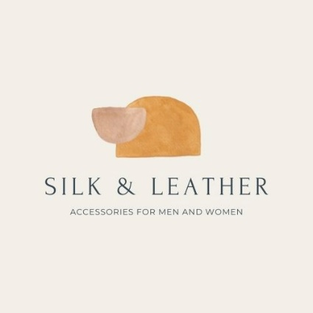

Silk & Leather Survey Template

(Input survey title, unit code and assessment) | Please tick your answer
 | Strongly disagree  ☐ | Disagree  ☐ | Neutral  ☐ | Agree  ☐ | Strongly  agree  ☐
 | Strongly disagree  ☐ | Disagree  ☐ | Neutral  ☐ | Agree  ☐ | Strongly  agree  ☐
 | Strongly disagree  ☐ | Disagree  ☐ | Neutral  ☐ | Agree  ☐ | Strongly  agree  ☐
 | Strongly disagree  ☐ | Disagree  ☐ | Neutral  ☐ | Agree  ☐ | Strongly  agree  ☐
 | Strongly disagree  ☐ | Disagree  ☐ | Neutral  ☐ | Agree  ☐ | Strongly  agree  ☐

